**Superintendent’s Corner**

Gary S. Reese, Ed.D.

Interim Superintendent

January 8, 2016

Happy New Year! I hope you had a restful December break. It’s hard to believe it is already January of 2016. Students were welcomed back to school on Monday, January 4th.

**Inauguration Ceremony**

Monday evening, the city of Amesbury’s tenth Inaugural Ceremony was held, with Peter Hoyt as the Master of Ceremonies. Three school committee members took the oath of office of school committee. Robert Chamberlain and Debra Ann LaValley were welcomed back for another term. They were joined by Gretchen Marinopoulos, the newest member of the school committee. Gretchen replaced long-time member Bonnie Schultz. I would like to extend our thanks to Ms. Schultz on behalf of the school community for her many years of dedicated service to the students of Amesbury as a parent, volunteer and school committee member. Another change for the school committee is the resignation of Christian Scorzoni. Mr. Scorzoni will continue to be involved in the community, as he won the Councilor at Large position on the City Council during the November election. In addition, Mr. Scorzoni was voted as council president for January 2016 – 2017. We thank Mr. Scorzoni for his dedication on the school committee; we look forward to his continued support of the schools in his role as City Councilor. With Mr. Scorzoni’s departure from the school committee, there is a vacant seat for which there will be a special joint meeting held between the school committee and city council to appoint a successor. Watch for more details about this process – if you are interested in serving and have any questions, feel free to give me a call or contact any of our current elected school committee members.

Mayor Gray was also sworn in for his second term as Mayor of Amesbury. His inaugural speech was one of optimism, pointing to the positive aspects of our community and the opportunity for continued growth. Mayor Gray expressed a continued goal regarding improving the school system. I look forward to working with him and all members of the community to make our schools a model of continued growth and improvement.

**MSBA – Amesbury Elementary School**

As the Mayor mentioned during his inaugural speech, we have been informed that the Massachusetts School Building Authority (MSBA) will be recommending to its board of directors that Amesbury be invited into the next phase of the school building process which is called feasibility study. This is an important next step in a process that began in the spring of 2015, when the city submitted a statement of interest (SOI) to the MSBA for support of a new Amesbury Elementary School. In October, the school was one of approximately 45 schools out of 97 communities that were visited by the MSBA team for a Senior Study visit. During that time, we highlighted the need for improved facilities. The MSBA then reviewed the submissions of those 45 schools and selected only 26 schools across the commonwealth to recommend for invitation into the next phase of the project. During feasibility, the district will identify its educational program, generate an initial space report, document existing conditions, and develop, design and recommend the most cost effective and educationally sound preferred solution to recommend to the MSBA Board of Directors. During this time, we will explore various options, including grade level configurations and school space options/availability throughout the community. This process will involve input from the schools and community – stay tuned for more information!

**In Case you missed the School Committee meeting of January 5th, 2016, here’s what you missed…**

*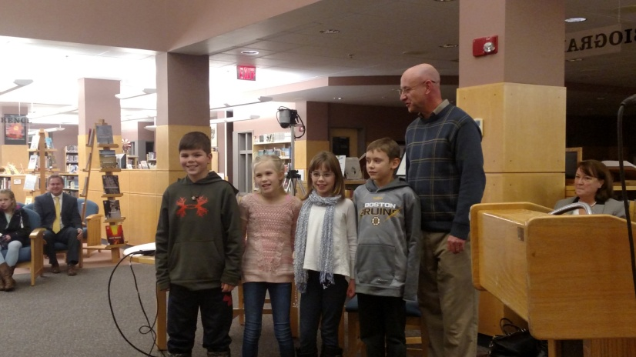Amesbury Elementary School presentation:* This year, the Amesbury Elementary School has changed its approach in promoting and recognizing citizenship and personal growth. This new model is more inclusive and allows for more students to be recognized for positive character traits. AES Principal Walter Helliesen, along with four student leaders, Brody Tonks, Ava Bezanson, Sam Guimaraes, and Naomi Smith, presented on the new program. It was another great example of students taking on leadership roles – the students were well poised and clearly articulated the benefits of the new program. In addition, a short video (2 – 3 minutes) with highlights from the first two showcase assemblies with some voiceovers from the kids explaining the process was presented.

*MCAS Accountability Presentation:* Ms. Lyn Jacques, Director of Teaching and Learning, provided the school committee with a presentation on the accountability levels of each of our schools and the district as a whole. Our district maintained its level two accountability status this year. Ms. Jacques identified that this was the accountability level for most districts across the commonwealth and that there were only three level one districts in the state. For her complete Powerpoint presentation, along with a document that defines key assessment and accountability terms, go to: <http://schools.amesburyma.gov/amesburypublic.cfm?subpage=1448253>

*Interim Director of Student Services:* Kevin Pierce, Director of Student Services, has accepted a new position in another district and completed his service to the Amesbury Public Schools in December. Because this position was becoming available mid-year, I felt strongly that we should appoint an interim director through the end of the school year and spend quality time interviewing for a permanent replacement that would begin on July 1st. I had the pleasure last night of introducing the recommended candidate to the school committee for final review and approval. Ms. Cindy Joyce is a retired Director of Special Education from the Saugus Public Schools. She has over forty years of experience in education and brings with her a wealth of knowledge. The school committee approved the appointment and Cindy started right away on Wednesday morning and is quickly acclimating herself to Amesbury.

**In Our Schools**

This week, my visits to the schools centered around visiting many of our special education programs with Ms. Joyce, the Interim Director of student Services. Ms. Joyce and I were impressed by both the quality of instruction, but also the range of strategies employed to meet the needs of students in those programs. In additional to visiting various special education programs, we also spent some time in the regular education setting and engaged in discussions about how to effectively include and support students with special needs into the regular classroom environment. Ms. Joyce had some great initial observations; I am excited to have her as part of the team and to watch as she ensures that ALL students are being provided with the most effective instructional models to promote success!

Be well and have a great weekend!

Gary